The structure of COMPASS-2 is defeated by the requirements for the CubeSat standards. The STR of COMPASS-2 is the mounting structure for all components of the system. The mounting system is the interface for the PCBs of each system, the battery, solar panels and for the payload. The structure is practically the skeleton of the satellite. The triple CubeSat specifications define the dimensions for COMPASS-2 with a nominal length of 100mm per X and Y axis. Only the Z axis length changes to 340.5 mm. The structure of the CubeSat must be strong enough to survive maximum loading defined in the testing requirements and cumulative loading of all required tests. The CubeSat structure must be compatible with the P-POD. The complete list of structural requirements for COMPASS-2 are descript in the CubeSat Design Specifications document (CDS).  
  
**Dimension and Mass Requirements:**  
[[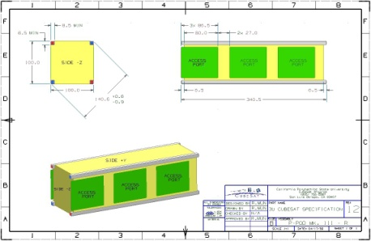](http://www.raumfahrt.fh-aachen.de/compass2/images/cds.jpg)  
*Figure 1: Access Ports*](http://www.raumfahrt.fh-aachen.de/compass2/images/cds.jpg)Normally CubeSats are cube-shaped picosatellites with a nominal length of 100mm each side. Dimensions and features are outlined in the CubeSat Specification Drawing. COMPASS-2 will become a nanosatellite with a normal x and y axis (100mm) and 340.5mm on the z axis. The mass may not exceed 4 kg and the center of mass has to be within 2 cm of its geometric center.  
  
**Structural Requirements:**  
The structure of the CubeSat has to be strong enough to survive maximum loading defined in the testing requirements and cumulative loading of all required tests and launch. The CubeSat structure has to be compatible with the P-POD.

* The CubeSat shall be 100.0 - 0.1mm wide (X and Y) and 340.5 - 0.3mm tall (Z).
* Rails have to be smooth and edges have to be rounded to a minimum radius of 1 mm.
* No external components other then the rails shall be in contact with the internals of the P-POD.
* Each rail shall be a minimum of 8.5mm wide.
* At least 75% (255.375mm of a possible 340.5mm) of the rail has to be in contact with the P-POD rails. 25% of the rails may be recessed and no part of the rails may exceed the specification.
* All rails have to be hard anodized to prevent cold-welding, reduce wear, and provide electrical isolation between the CubeSats and the P-POD.
* Separation springs have to be included at designated contact points (Appendix A). Spring plungers are highly recommended (McMaster-Carr P/N: 84985A76 available at http://www.mcmaster.com). A custom separation system may be used, but has to be approved by Cal Poly launch personnel.
* The use of Aluminium 7075 or 6061 is suggested for the main structure. If other materials are used, the thermal expansion has to be similar to that of aluminium 7075-T73 (P-POD material) and approved by Cal Poly launch personnel.

**Picosatellite Deployer:**  
[[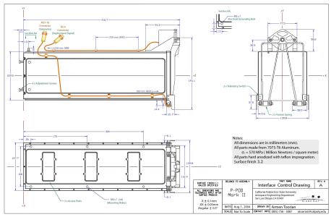](http://www.raumfahrt.fh-aachen.de/compass2/images/deploayer_drawing.png)](http://www.raumfahrt.fh-aachen.de/compass2/images/deploayer_drawing.png" \t "_blank)*[Figure 2: Drawing P-POD](http://www.raumfahrt.fh-aachen.de/compass2/images/deploayer_drawing.png" \t "_blank)*A unique feature of the CubeSat program is the use of a standard deployment system. The Poly Picosatellite Orbital Deployer (P-POD) standardization provides the interface between the launch vehicles and the CubeSats. This reduces mission costs and development time. The P-POD has been fully qualified according to NASA worst case vibration levels and thermal vacuum environments.  
The current P-POD is capable of containing and deploying three single CubeSats. The POD is made by Al 7075 T-73. During the launch phase the POD is locked by a hatch which will be opened by a mechanism when the scheduled orbit is reached. After the mechanism has released the hatch-lock a spring separates the spacecraft from the launch vehicle pushing the spacecraft out of the POD. CubeSats are stacked inside the P-POD and constrained by a set of hard anodized Teflon-impregnated rails. These rails provide a low-friction surface while the CubeSat are deployed.  
  
**Testing:**  
Testing must be performed to meet all launch provider requirements as well as any additional testing requirements deemed necessary to ensure the safety of the CubeSats and the P-POD. All flight hardware will undergo qualification and acceptance testing. The P-PODs will be tested in a similar fashion to ensure the safety and workmanship before the CubeSats will be integrated. All CubeSats have to accomplish the following tests.

* **Vibration Test**  
  Vibration tests serve the simulation of dynamic mechanical charges. It is tested with oscillations in the frequency response of 1 to 2000 Hz.
  + Transient or virtual harmonious in the low frequency response (1 to 100 Hz)
  + Chance-distributed in the high frequency response (20 to 2000 Hz) The goals of vibration tests are:
    - Proof of the durability against the appearing dynamic loads
    - Verify the faultless function of each system

For the vibration test, the satellite is housed in a test POD which is mounted to a shaker table. During the vibration test the POD, which contains the satellite, should show no natural harmonics. The dened vibration loads are measured immediately by acceleration sensors, which are mounted on dened points to the test POD. To improve the measured values, several sensors are monitoring the vibration behaviour. All these values are computed to an average value for further analyses. The vibration loads are initiated successively through three vertically main axis in the test object.

* **Solar Simulation Test**  
  The solar intensity in the low-earth-orbit is about 1371 *W/m2*. With the sunsimulator the effects from the high radiation to the spacecraft are tested. The sun-simulator is using a xenon lamp to simulate the radiation to the satellite. The spectrum of this lamp is except of a spectral peak, caused by the properties of xenon - very similar to the natural sun light.
* **Thermal-Vacuum Test**  
  During this test, the satellite is put into a high vacuum-chamber for several temperature cycles. Besides the number of cycles as well as the temperature thresholds for heating up and cooling down depending on the mission objectives are tested. Usually the temperature thresholds for the cooling phase are between -100°C and -180°C and for the heating phase +80°C and +130°C.
* **Acoustics Test**  
  During the launch phase of the satellite, the rocket induces sound-loads to the spacecraft structure. This sound pressure generates high loads, especially in thin parts like solar cells and PCBs. To avoid unmeant damage, the satellite has to be tested before, to confirm the sound pressure stability. To execute these tests, an acoustic noise room is necessary, which guarantees a long echo time based on its design. Standing acoustic waves can be generated. This is necessary to fulfill the requirements for the noise levels. The sound waves are generated by compressed air which is passing through special valves to excite the required frequency for the testing procedure.   
  First of all the satellite is tested in a level of 8 dB and 6 dB lower than the qualification level. As Second the satellite is tested in a level of 3 dB under the qualification level. Then the test with the qualification level follows and finally a low level test again. Then the measured values of both low level tests of the structures answers are compared to conclude a possible change of the structure properties. To verify the calculation of the loads the structure answers from the decline and qualification tests are compared from the classification level.

All tests, exapting the acoustics test, will be will be executed at the FH Aachen.