**Primary Communications (PCOM/COM)**

**Subsystem Top Level Requirements  
--** The system shall be a full-duplex, bidirectional data communications system  
**--** The system shall follow the AMSAT guidelines for VHF and UHF communications to and from space  
**--** The system shall be compatible with the Boulder Colorado Space Grant Consortium ground station using the AX.25 protocol

**Subsystem Functional Requirements  
--** The system shall not exceed a mass of 150 grams and a volume of 200 cm^3  
**--** The system shall provide an uplink and downlink data rate of at least 1200bps  
**--** The system shall maintain a link margin of at least 3dB at elevations greater than 20 degrees  
**--** The system bit error rate shall be less than 1*10^-5 at elevations greater than 20 degrees  
**--** The system shall not consume greater than 8 Watts of peak power when transmitting  
**--** The system shall not exceed 0.25 Watts of power in standby  
**--** The system shall provide a control method for CDH to control the state of the system including push-to-talk and programming of the radio

The Primary Communications (PCOM) subsystem is the initial method of communication with the satellite. **Antenna Design**The spacecraft is designed to receive transmissions from the ground on the 150MHz, 2 meter frequency, and transmit on the 428MHz, 70cm frequency. Since almost any piece of metal is capable of receiving radio transmissions, focus was placed on optimizing the PCOM antenna for transmission.

Antenna gain pattern and standing wave ratio (SWR) analyses were completed using the 4NEC2X software package. This is a free interface for the NEC antenna model and can be downloaded [here](http://home.ict.nl/~arivoors/index.html). After numerous antenna analyses ranging from monopoles to dipoles to eggbeater antennas, a crossed-dipole antenna with two elements 33 cm long and 90 degrees out of phase yields the most beneficial gain pattern for transmitting on the 70cm band. The antenna is circularly polarized and offers a near-isotropic gain pattern. The obvious benefit to such an omni-directional antenna is that it loosens the pointing requirements on the ADCS subsystem. The below gain plots demonstrate the worst possible gain scenario for the antenna. The SWR of the crossed-dipole antenna is 1.506, which is about half of the maximum allowable value of 3.

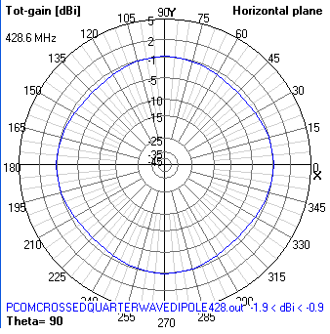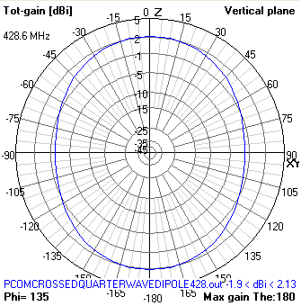  
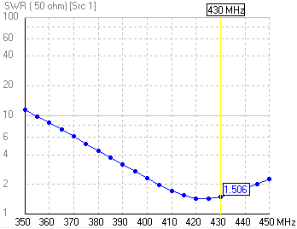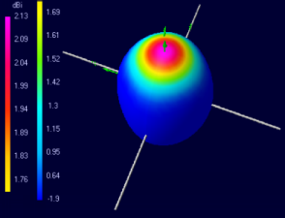

**Link Margin and Analysis**The link budget was calculated using a two-step modeling process. The first step was the completion of the AMSAT/IARU Annotated Link Margin System in Microsoft Excel format developed by Jan A. King. For this portion of the analysis, an isotropic gain pattern was assumed for both the uplink and downlink spacecraft antennas.

The second part of the link analysis incorporated the results of the AMSAT/IARU analysis with orbital data provided by Satellite Tool Kit (STK) into a Matlab script. This allowed for accurate modeling of satellite spin and magnetic field alignment.

Since the PCOM antenna is mostly isotropic (only differing by 4dB at any point) it is modeled in the Matlab analysis as an omni-directional antenna having a gain of -2dB. This is the lowest gain in the antenna gain pattern and thus provides a worst case scenario for the link budget. Even using this worst case value, a positive link still exists at all elevations above 5 degrees. This yields a total of ### minutes of possible PCOM communication time per week. The majority of these communication passes last about five minutes.

**Terminal Node Controller (TNC)**The TNC is an in-house creation built from plans available on the internet. Plans were modified for full-duplex operation and full coverage of the AX.25 protocol. The TNC utilizes two AVR microcontrollers, one for transmit (TX) and one for receive (RX).

The TNC is currently in the prototyping stage and issues have risen regarding the RX error rate. With the current design, it appears that only about 70% of data is received correctly, in other words, a 30% error rate. This is an unacceptable amount of error and investigation is being done into other TNC designs that have error rates of less than 10%.

**Radio/Transceiver**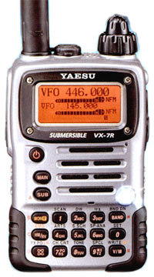The spacecraft radio for Hermes is the Yaesu VX-7R, a full-duplex transceiver capable of transmitting on one band and receiving on another band simultaneously. This functionality is critical for the satellite to be able to receive commands while down-linking data. This also offers a method for shutting down the radio should it cause harmful interference. Without full-duplex functionality, we would have to wait for the satellite to finish sending its data before being able to send other commands.

The radio will be removed from its casing and stripped down to the minimum possible size and mass. The largest caveat of using a commercial off-the-shelf (COTS) radio like this one is its inefficiency. It requires an input of 6-7 Watts of power to generate just 1 Watt of transmitting power. However, at only US$370 this radio was the best option for our limited budget. More efficient radios are available, but at a cost well beyond what we can afford.