DTUsat Radio System Summary
Revision history:
First posted March 6th 2003
March 8th: Added driver interface
March 9th: Changed turn around delay and driver operation procedure, added command- and measurement interface description
March 10th: Added environmental section and pictures. Framework is now complete as far as I can tell – please correct me if I am wrong.
March 13th: Status updates
Preliminary, last edited March 13th 2003
Parts in Danish are not finished.

Most recent version is found at:
DTUsat -> SysEng -> Files -> Systembeskrivelser -> Radio System Summary.doc/pdf

Contact information:
Niels Holmgård Andersen, niels@holmgard.dk, (+45) 6171 7742

Picture of Prototype
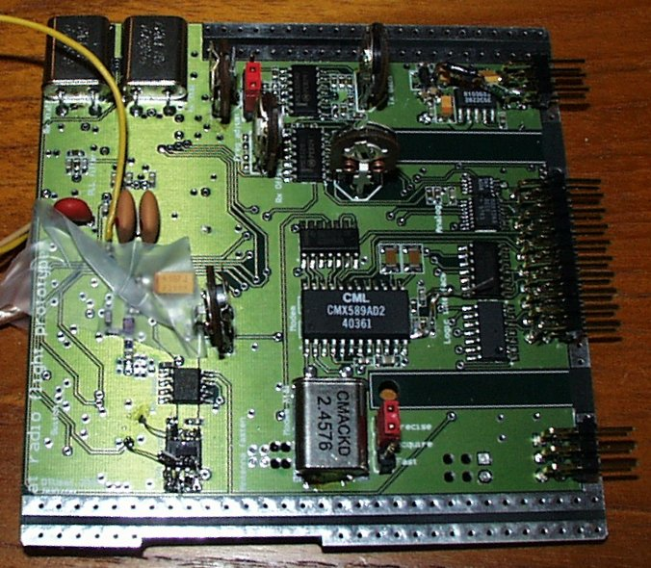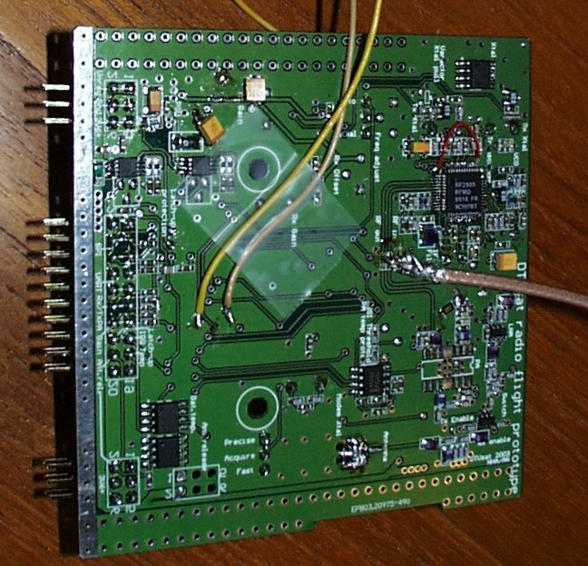
Bottom – inner layer in PCB cube Top – outer layer in PCB cube
Crystals, logic and LF circuits. Tall cmpnts. RF circuits and miscellaneous

System Function
Communication with ground station by a 437.475 MHz, 25 kHz bandwidth radio link
Modulated using padded G3RUH at 9600 bps narrow-band FM
Transmitted power adjustable from ca. -11 dBm to 25-29 dBm dependent on Vunreg
Spectral purity currently -45 dBc.

System Status
The radio prototype is still under test. Hopefully, the prototype will be checked out on Monday, 10th of March. Update: Not very likely, but perhaps March 13th or 14th …

A flight PCB will then be designed and manufactured. Testing the flight board should be doable in two days. If nothing fails during this very tight schedule, the flight board should be ready for integration by March 17th. However, given Murphys law…

Modem transmit section is functional.
Basic transmitter is functional and the frequency is accurate.
Modulation index and channel width are fine.
PA is tested and functional.
Noise measurements are not yet done, but preliminary results do not look very good.

Receive amplifier chain is tested and functional.
Basic receiver is tested until end of IF chain, is functional, but is known to be under specs due to wide filters. Narrower filters have been ordered.
Demodulator is faulty and will need a complete rework. I am working on it.
Modem receive section is functional.

Antenna interface circuit (switch, filter) is tested and functional.

Power supply is functional.
Conducted return noise to PSU is not yet tested.
Antenna release is functional.
Power switching for the PA is functional.
Modem interface to OBC/ground station is tested and functional.
SPI measurements are tested and functional.
Latch-up is known not to work, but the revisions have been tested by OBC and works.

PA has not yet been tortured (shorted output etc.)
Nominal ranges in engineering units are not yet found.
Exact output characteristics are not yet found, and will not be characterized until after shipment of flight model to Canada using the flight spare.

Mass Budget
Radio PCB: final 40 g including OBC pins
Antennas: final 70 g including –Z panel, power splitter PCB and release system
Harness: max 5 g coax cable and antenna release cables
Wish list: max 10 g conformal coating on power splitter PCB, black paint,
epoxy vacuum protection of crystals
Total 120 g

Physical Dimensions and Board Overview
Mechanical integration of the complete –Z side has been performed on 10th of March. One problem was found: The magnetorquer collides with OBC. This has been fixed by moving the magnetorquer 2 mm.

Mål på printet - målt fysisk incl. byggehøjde i zoner, hvor over 2 mm
Oversigt over hvor på printet de forskellige delkredsløb befinder sig – specielt ledningsplaceringer og temperatursensorer.

Power Budget
Quiescent current draw
3V6 23 mA (will probably be about 15 mA in flight version)
Vunreg 0 mA

Receiving
3V6 33 mA (will probably be about 25 mA in flight version)
Vunreg 0 mA

Transmitting
3V6 33 – 55 mA depending on commanded output power
Vunreg 100 – 450 mA depending on bus voltage and gain settings

Antenna release
3V6 23 mA (no impact)
Vunreg 750 mA at 3.8V, up to 1000 mA at 5V. Scales with bus voltage.
Do not operate any other parts drawing considerable current while deploying antennas.

Latch-up limits are set at
3V6 100 mA
Vunreg 1200 mA

Environmental Properties
Vacuum
The radio has not yet been tested in vacuum, but an inert model has been exposed without any visible defects.

The only possible problem anticipated is crystal deterioration, which will be countered on the flight model by sealing the soldered edges of the crystal package with epoxy.

Temperature
The radio transceiver chip, logic and analog interface is tested from -30 to 60 degrees without problems

Frequency drift as a function of temperature:
(Indsæt kurver fra spectrum analyzer)

No other problems are anticipated, as the modem is specified from -40 to 85 degrees and as the associated crystal is free running – the clock recovery from the modem is PLL controlled.

Radiation
The radio transceiver chip is tested to 10 krad without measurable effects. No other radiated chips have been tested. Main unknown is the opamp- and modem circuits – logic interface, discretes and large MOSFETs are not likely to cause trouble. The processes used for the RF front-end are radiation tolerant (bipolar, HBT and GaAs).

The LF chips are placed on the inside of the PCB cube, which will add a layer of radiation protection.

10-20 krad TID should not cause any problems.

Latch-up has not been tested for any components, but standard latch-up protection using the MAX4375 has been implemented using the values stated in the power budget. Only two channels are implemented, so small latch-ups might not be detected in hardware.

Vibration
The radio has not yet been vibration tested.

No problems are anticipated.

Hardware Interface
Stikforbindelser, polaritet, betydningen af signalet
Ledningsforbindelser til andre delsystemer og signalbeskrivelse
Physical placement will be indicated on the board overview at a later time.

Command Interface
General remarks
Main controls for the radio are TxE and RxE, enabling the transmitter and the receiver, respectively. Both inputs are active high. Do not enable both at the same time, as this might damage the radio. If both inputs are low, the radio is disabled and uses minimum power. It is not necessary to power down other inputs (e.g. DAC commands) to power down the radio, as the values will be stored. Boot values are all zeros.

DAC channels
The radio DAC is a MAX549A enabled by RADIO SPI SEL 2
Channel 0 (“A”) controls the Tx RF level on the transceiver chip from about -13 to about +4 dBm for EU of 0 to 255. The control is approximately linear.
Channel 1 (“B”) controls the carrier bias from about -7 kHz to about +2 kHz for EU of 0 to 255 EU. The control is not linear; the setting for no deviation is about 145 EU. Avoid the outer range of this control, as this will stop the modulation from working.

Gain settings
Basic PA gain is about 6 dB
Gain8 adds about 8 dB PA gain
Gain16 adds about 16 dB PA gain
Max gain is about 30 dB

The gain is added to the output of the transceiver chip as commanded by DAC channel 0. By subtracting the loss of the antenna interface circuits and the power splitter, the RF output of the satellite can be calculated. The exact loss is TBD, but is expected to be about 2 dB total.

UART interface
Ikke beskrevet endnu
IRQ

Antenna release interface
Taking the single pin AntRel high enables the power switch for the antennas.

Latch-up interface
The radio is using a standard latch-up protection scheme copied from OBC. The output is a number of open collectors tied together. Latch-up limits are described under Power Budget.

Measurement Interface
The temperature sensors and the SPI components are always powered, so measurements can be made at any time. However, they do not always have physical significance.

Analog-to-digital converter
The radio ADC is a MAX1248 enabled by RADIO SPI SEL 1
Channel 0 measures RxD DC level on the transceiver chip. This is a measure of the tuning accuracy when receiving. It is not possible to do anything about it except reporting it to the ground station. This measurement is only valid if RxE is high. Range TBD.
Channel 1 measures RSSI, short for Received Signal Strength Indicator, on the transceiver chip. This does exactly what the name says. This measurement is only valid if RxE is high. Range TBD.
Channel 2 measures SNR, an output from the modem. High SNR means very accurate zero crossings in the received signal. This measurement is only valid if RxE is high. Range TBD.
Channel 3 measures Iunreg. This measurement is always valid, but is only interesting if TxE or AntRel are high. Range TBD.

The radio ADC will probably be changed to the 8-ch MAX1281 on the flight board to measure more channels, most notably Ireg and Vunreg, to facilitate stand-alone calibration of the transmitter.

Temperature channels
The radio prototype has 3 one-wire DS18B20 temperature sensors on board

Measurement ID 64 bit one-wire ID Housekeeping ID
Radio crystals TBD Software -
Radio PA TBD decision
Radio antenna switch/battery mount TBD

The flight board will have one more DS18B20:
Radio PSU TBD

Physical placement will be indicated on the board overview at a later time.

Driver Interface
To receive:
Set TxE low
Wait min. 5 ms
Set RxE high
Wait for IRQ (comparator on RSSI) or RSSI level measurement above nothing (optional)
Wait for SNR level (optional)

Receive data on UARTRxD sync’d by UARTCLK

To power down:
Set RxE low
Power down sequence is not critical, as all controls are protected on board.

To transmit:
Check for unregulated bus voltage above 3.3V
Measure temperature at crystals and calculate carrier bias (optional)
Set Gain8, Gain 16 to desired PA gain (normally both high)
Set DAC ch0 to desired RF output (normally high, about 200 EU (TBD))
Set DAC ch1 to carrier bias (normally about 1.4V, 110 EU – slightly temperature dependent)
Set RxE low
Wait min. 5 ms
Set TxE high

Transmit data on UARTTxD sync’d by UARTCLK
Check PA current level, unregulated bus voltage and temperature at regular intervals
Check temperature at crystals and calculate carrier bias at regular intervals (optional)

To power down:
Set TxE low
Power down sequence is not critical, as all controls are protected on board.
Gain8 and Gain16 can be left unchanged.
Commanded values for RF output and carrier bias are stored on board.

To release antennas:
Check conditions for antenna deployment described elsewhere
Check for unregulated bus voltage above 3.8V
Check current draw – bus must be at minimum load
Set AntRel high
Check Vunreg current level rise to at least 750 mA
Hold AntRel high for 3 minutes
Set AntRel low

No damage is done by repeating the procedure at a later time (except energy waste)

Driver Traps and Protection
TxE and RxE must never be high at the same time. This might damage the radio.

The transceiver is not able to switch instantly between transmit and receive due to the mechanical nature of the crystals. A delay of 5 ms must be observed. No damage is done, but the LO will stay in the wrong frequency if the delay is not observed, causing communication loss.

The PA is able to burn itself out. The radio PCB is equipped with an autonomous hardware temperature protection, which will cut the power to the PA if the temperature is above 75 degrees. Due to lack of pins, this is not reported to OBC. A separate digital temperature sensor is available for software feedback. Also, the current draw from Vunreg will drop to less than 10 mA, signifying PA power down.

The current draw of the PA should never exceed 450 mA. This can happen if Vunreg is very high (>4.5V) and the commanded power is high. This is monitored using an onboard current sensor, but no autonomous protection system is built in. If it happens, reduce commanded power by lowering DAC channel 0.

Do not operate the PA when Vunreg is less than 3.3V. Apart from that the satellite is dangerously close to emergency shut down, which may be triggered by the increased load, the PA can be damaged if the control inputs are more positive than the power input. No autonomous protection is built in.

The receive section is far from optimal. For safety reasons, I recommend that the boot software tries booting the application software autonomously after a couple of days without ground station contact.

Integration test
The most difficult part of the integration test between OBC and radio has been completed successfully. The path
Boot software <-> OBC USART <-> radio modem <-> wire <-> buffer amplifier <-> soundmodem <-> raw packet interface
Has been tested and is working.

Work is still in progress on increasing soundmodem performance in presence of noise. This will be tested against a hardware TNC, probably Thursday March 13th.

The remaining part is the housekeeping interface (measurements via ADC and temperature sensors) and the radio command interface (PA and output settings via DAC).

The path
Test software <-> radio modem <-> RF circuits <-> Antenna <-> Ground station
Has not yet been confirmed.

When these two separate tests are checked out, we are ready for a full scale communications test.

Requirements for the test are:
OBC
Power, battery or solar powered at ground level
Antennas
Ground station
Software support for ground station and boot software
Debugging interface and laptop
RF measuring equipment available at EMI
Distance and preferably elevation – e.g. the tall apartment building at Klampenborgvej or (better) the SAS hotel in Lyngby

This test is pending, awaiting completion of the RF circuit module test and ground station test.

Also pending is a final antenna release test using the real power supply

Inspection Procedure
Still preliminary values – better values will be provided after checkout of the flight board.

Visual check:
Check antenna fasteners and wire positions
Check for residual glue under antenna wire at binding positions

Check antennas electrically shorted to satellite surface at DC, isolated at RF

Software check:
Verify temperature sensors functional and showing ambient temperature
Current draw <25 mA reg, <1 mA unreg measured using on-board current sensors

(The next block must be automated and performed within max 1 second to avoid damage to PA - TBD)
Command Gain8, Gain16 low
Command TxE high: Increases current draw to about 35 mA reg, 100 mA unreg
Toggling Gain8, Gain16 and DAC output changes unreg current draw to a maximum of 450 mA
Verify CLK-pulses from modem
Command TxE low: Current draw back to <25 mA reg, <1 mA unreg
Verify temperature increase in PA temp sensor (probably too small in 1 sec, but could be…)

Command RxE high: Increases current draw to about 35 mA reg, <1 mA unreg
Verify CLK-pulses from modem
Verify signal from RSSI, SNR circuits (will be low given no ground stations nearby)
If possible, inject a 437.475 MHz signal and check for RSSI increase, SNR, received data
Command RxE low: Current draw back to <25 mA reg, <1 mA unreg

Applicable stimulation of the completed satellite for complete verification:
A reasonably powerful RF signal (e.g. 0 dBm) will probably be able to get through to the radio, even if the antennas are folded (TBD). This enables a test of the receiver as long as the satellite has not yet been locked up in the P-pod (which will act as a very efficient faraday cage).

It is not practical to test RF transmit with the antennas folded, but it might be doable for short packages without endangering the PA. TBD. Do not try this at home :-)

Technical Documentation
Indsættes efterhånden. Printtegninger, diagrammer, datablade på anvendte komponenter

