**Main Tasks:**  
The functions of the electrical power system are to generate and store electric power for use by the other spacecraft subsystems. The subsystems may have various specific requirements for voltage, frequency, stability, noise limits or other characteristics, and the power system has to supply them. The power system also has to load the batteries. Deciding in which mode the system is operating, like the "nominal-mode", "safemode" or the "emergency-mode", is also a part of the EPS.   
To maintain the long-term reliability of the system, the power system must provide protection to other subsystems against fatal failures of subsystems. For example, no short-circuit in another subsystem should drag the main bus voltage down to the point of inducing failure anywhere in the spacecraft. Similarly, failure protection will be implemented in the power system itself to allow a continuous function of the other spacecraft systems.  
  
[[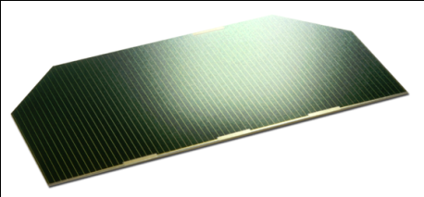](http://www.raumfahrt.fh-aachen.de/compass2/images/solarcell.png)](http://www.raumfahrt.fh-aachen.de/compass2/images/solarcell.png" \t "_blank)*[Figure 1: Solar Cell](http://www.raumfahrt.fh-aachen.de/compass2/images/solarcell.png" \t "_blank)***Power Source (Solar Cells):**  
For the power source, COMPASS-2 has 30 solar cells on the surface. Three of the long sides will contain eight solar cells and the fourth long side will contain six solar cells. The solar cells will have a 30.5% efficiency. With this solar cells, the satellite will give an average power output of 4.8 Watt in vertical flying and 3.9 Watt in horizontal flying.  
  
**Power Storage (Batteries):**  
[[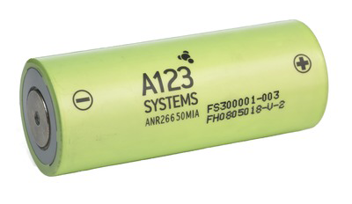](http://www.raumfahrt.fh-aachen.de/compass2/images/battery.png)](http://www.raumfahrt.fh-aachen.de/compass2/images/battery.png" \t "_blank)*[Figure 2: LiFePo Battery](http://www.raumfahrt.fh-aachen.de/compass2/images/battery.png" \t "_blank)*For the COMPASS-2 satellite the newest battery technology will be used, Lithium Ferrum Polymer (LiFePo). The satellite will have a redundant charging system with two batteries to reduce the charging cycles for each battery. Due to the fact, that the batteries aren´t space proofed one of the workspace of the EPS system is to testing the batteries for their work in space. The STR will develop a batterie case, if necessary.  
  
**Power Distribution & Control:**  
One of the biggest workspace for the EPS system is to control and distribute the available power. For this work field good programming skills are needed. The system will set the satellite in three different modes.

* Nominal Mode
* Power Save Mode
* Emergency Mode

Also it is necessary that the groundstation can control the different modes and the settings. The three modes need to be tested to.