**Main Tasks of Communication:**  
Communications architecture is the arrangement of the satellite and the ground stations and their communication between each other. The communication subsystem will define, test and develop a communication system for COMPASS-2 based upon the COMPASS-1 Communication System. The first step is to define the mission objectives and requirements in order to have enough criteria for the development complexity. We have to specify the amount of data in mission operation and the access time, the time of a yover. As a second step we have to analyse the possible data rates for the downlink. Therefore it is necessary to decide if there will be data processing to compress the data aboard the satellite or not. As a third step we have to know roughly the amount of ground stations additional to the ground station at the FH-Aachen. We have to figure out the availability of a radio frequency spectrum, the transmission modulation and transmission speed, the coverage of the satellites antenna beam and the path length between the satellite and ground station in order to calculate the antenna size and the transmission power. In comparison to COMPASS-1, this mission will have a focus on channel coding and adaptive modulation in order improve the amount of data transferred during each yover. This also includes smart software at the ground station for signal processing. The fourth step is to estimate the size and mass of the antennas and the PCBs (printed circuit board).  
  
[[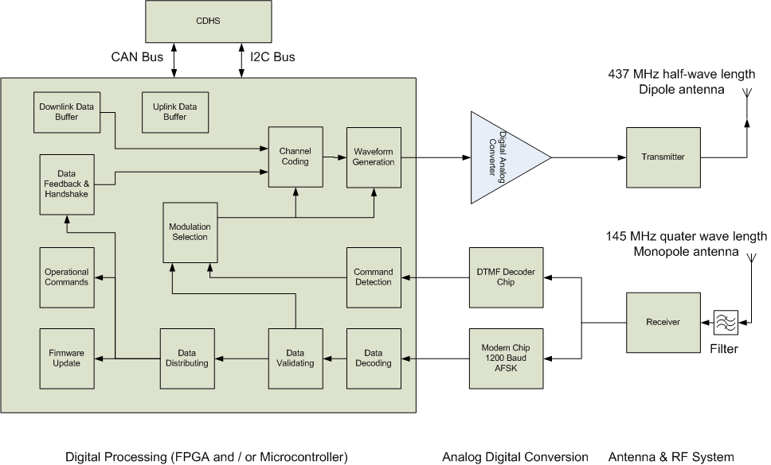](http://www.raumfahrt.fh-aachen.de/compass2/images/com_layout_wilke.png)  
*Figure 1: Internal Layout of the COM subsystem*](http://www.raumfahrt.fh-aachen.de/compass2/images/com_layout_wilke.png)**Modulation Methods:**  
Due to the system design, the modulation signal can be created by the COM micro controller. This gives the chance to do all the modulation signal processing inside the software. Just one transmitter is needed for all transmission types. The software defines which one is used at which moment. The base band waveforms are calculated inside the software and fed into a digital-analog-converter. Here the digital waveforms are converted into voltages. A well-dimensioned antialiasing filter is used to create a high-quality modulation signal. Depending on the actual demands and link quality, modulation is adaptively and automatically changed by handshaking with the operating ground station. As an experimental addition, hierarchic modulation is used to allow two or more different data rates at same time.   
As the COMPASS-2 group is expecting support and help from ham radio enthusiasts all over the world, the transmission modulation must be compatible to standard ham radio operator's receiving equipment. This means non-coherent receiving with channel width of maximum 6 kHz. Thus, all phase concerning modulations are a no-go.   
The ground station software will include the possibility for channel equalization, paying attention to the non-linear frequency response of ham radio receivers.  
  
**AFSK:**  
Audio frequency-shift keying is a modulation technique in which digital data is represented by changes in the frequency (pitch) of an audio tone, yielding an encoded signal suitable for transmission via radio or telephone. Normally, the transmitted audio alternates between two tones: one, the "mark", represents a binary one; the other, the "space", represents a binary zero. AFSK di  
ers from regular frequency-shift keying in performing the modulation at base band frequencies. In radio applications, the AFSK-modulated signal normally is being used to modulate an RF carrier (using a conventional technique, such as AM or FM) for transmission. AFSK is not always used for high-speed data communication, since it is far less ecient in both power and bandwidth than most other modulation modes. In addition to its simplicity, however, AFSK has the advantage that encoded signals will pass through AC-coupled links, including most equipment originally designed to carry music or speech.   
  
**FSK:**  
FSK is a frequency modulation scheme in which digital information is transmitted through discrete frequency changes of a carrier wave. The simplest FSK is binary FSK (BFSK). BFSK literally implies using a couple of discrete frequencies to transmit binary (0s and 1s) information. With this scheme, the "1" is called the mark frequency and the "0" is called the space frequency.   
  
**n-FSK:**  
As an improvement of FSK (which is also call 2-FSK), n-FSK uses not just two discrete frequencies. Dening n orthogonal frequencies and assigning n bits to those sub carriers, it is possible to transfer n bit at the same time. The advantage is the higher e  
etive data rate, the disadvantage is that a higher signal-to-noise-ratio (SNR) is needed. The SNR is a measure for the link quality, which varies during a yover depending on the actual weather conditions and elevation above the horizon. Due to that changing link quality, an adaptive modulation is choose the right n to maximum data speed.   
  
**Hierarchic modulation using FSK:**  
As an experiment still to be defined by a Diploma Theses, hierarchic modulation using FSK will be used to allow different data speeds at the same time using complex channel coding. The higher data rate needs high link quantity to be decoded properly. The lower one is receivable with high noise impact. A possible appliance is still picture streaming with di  
erent resolutions at the same time.  
  
**AX.25 Protocol:**  
During the physical transmission of data to and from COMPASS-2 errors can occur. To avoid this problem a transmission protocol is urgently required. This protocol is used to encode, decode and process the information and it is used to transmit data between a computer and a terminal node controller on a radio channel.   
The AX.25 protocol is a data link layer protocol, which is deduced from the X.25 protocol standard. This seems to be the most suitable protocol for our application. It is mainly used at amateur packet radio and it is emerging to be the standard for Cubesat systems. Also COMPASS-1 used this data link layer protocol to encode the data.   
AX.25 encapsulates the data in "packets", which consist of data frames. This happens in the protocol layers of the OSI networking model standard. AX.25 uses the rst layer (physical layer), the second layer (data link layer) and the third layer (network layer).  
AX.25 is often used with a TNC (Terminal Node Controller) that implements the KISS framing as an alternative to using an expensive HDLC controller card. The KISS framing is not part of the AX.25 protocol itself nor is it sent over air. Actually, it serves to encapsulate the AX.25 frames in a way that they can pass over a serial link to the TNC successfully.   
  
**OSI-Layer:**  
[[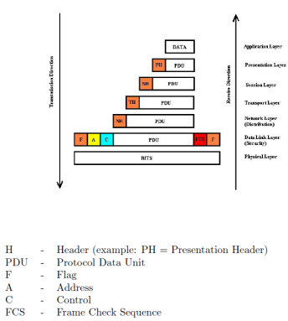](http://www.raumfahrt.fh-aachen.de/compass2/images/osi_layer_model.png)](http://www.raumfahrt.fh-aachen.de/compass2/images/osi_layer_model.png" \t "_blank)*[Figure 2:  
OSI Layer Model](http://www.raumfahrt.fh-aachen.de/compass2/images/osi_layer_model.png" \t "_blank)*Due to the development of open telecommunication systems in the mid eighties, the Open Systems Interconnection Reference Model (OSI Reference Model or OSI Model) was issued by the International Standards Organization (ISO).   
It consists of 7 hierarchically structured protocol layers. However, the AX.25 is only using the three lowest layers. Nevertheless it is necessary to understand the AX.25 protocol and to know the schematic structure and the basic function of the whole OSI Layer Model (Figure 2).   
The Sending System encapsulates the Information in the PDU and sends the data to the next layer which adds a header to the whole signal and gives it to the next layer and so on. In the Data Layer Flag-, Address-, Control-bit are added and also the FCS.   
  
**Physical Layer (Bit Level):**  
The Physical Layer is the rst and lowest level in the seven-layer OSI model of computer networking.   
The Physical Layer describes the basic hardware transmission technologies of a network. It is a fundamental layer underlying the logical data structures of the higher level functions in a network. Due to the quantity of available hardware technologies with widely varying characteristics, this is perhaps the most complex layer in the OSI architecture.  
The Physical Layer defines the means of transmitting raw bits rather than logical data packets over a physical link connecting network nodes. It provides an electrical, mechanical, and procedural interface to the transmission medium. The shape and properties of the electrical connectors, the frequencies to broadcast on, the modulation scheme to use and similar low-level parameters, are specified here.

* Defines electrical and physical specifications for devices
* Controls connection between device and physical medium
* Is responsible for character encoding, transmission, reception and decoding
* Enables auto negotiation during data transmission
* Translates Logical communication requests from the Data Link Layer into hardware specific operations, which effect transmission of reception of electronic signals

**Data Link Layer:**  
The Data Link is the second Layer of the OSI model of computer networking. It is the protocol layer which transfers data between adjacent network nodes in a wide area network or between nodes on the same local area network segment. The Data Link Layer provides the functional and procedural means to transfer data between network entities and might provide the means to detect and possibly correct errors that may occur in the Physical Layer.  
Delivery of frames by layer 2 devices is affected by the use of dedicated hardware addresses. A frame header contains source and destination addresses that indicate from which device originated the frame and which device is supposed to receive and process it. In contrast to the hierarchical and routeable addresses of the network layer, layer 2 addresses are flat, meaning that no part of the address can be used to identify the logical or physical group to which the address belongs.

* Enables reliable, mostly correct, data transfer and controls the access to the transfer device
* Features error detection by segmenting bit ow into blocks/packages, numbering them and adding a checksum/hash sum
* Allows multiplexing of protocols
* Determines the frame size and therewith provides ow control
* Responds to service requests from the Network Layer and performs the functions by issuing service requests to the Physical Layer

**Network Layer (Packet Level):**  
The Network Layer is the third Layer of the OSI model of computer networking. It is responsible for end-to-end (source to destination) packet delivery including routing through intermediate hosts, whereas the Data Link Layer is responsible for point to point frame delivery on the same link.  
The Network Layer provides the functional and procedural means of transferring variable length data sequences from a source to a destination host via one or more networks while maintaining the quality of service and error control functions.  
Functions of the Network Layer include:

* Connection model: connection - oriented and connectionless communication
* Host addressing
* Message forwarding
* Enables connection-oriented and connectionless communication
* Features functional and procedural means of transferring different data sequences from source to destination host via one or several networks and still maintains the quality of service and error control functions
* Responds to requests from the Transport Layer and issues requests to the Data Link Layer

**Frame Structure:**  
Link layer packet radio transmissions are sent in small blocks of data, called frames. Each frame is made of several smaller groups, called fields. Fig.1 shows the three basic types of frames. Note that the first bit to be transmitted is on the left side. 

|  |  |  |  |  |
| --- | --- | --- | --- | --- |
| First Bit Sent | | | | |
| Flag | Address | Control | FCS | Flag |
| 01111110 | 112/560 Bits | 8 Bits | 16 Bits | 01111110 |

|  |  |  |  |  |  |  |
| --- | --- | --- | --- | --- | --- | --- |
| First Bit Sent | | | | | | |
| Flag | Address | 8 Bits | PID | Info | FCS | Flag |
| 01111110 | 112/560 Bits | 8 Bits | 8 Bits | n·8 Bits | 16 Bits | 01111110 |

Each field is made up of an integral number of octets and serves a specific function as outlined below.  
  
**Flag Field:**  
The fag field is one octet long. Since the fag is used to delimit frames, it occurs at both the beginning and end of each frame. Two frames may share one flag, which would denote the end of the first frame, and the start of the next frame. A flag consists of a zero followed by six ones followed by another zero, or 01111110 (7E hex). As a result of bit stuffng (see 2.2.6, below), this sequence is not allowed to occur anywhere else inside a complete frame.   
  
**Address Field:**  
The address field is used to identify both, the source of the frame and its destination. In addition, the address field contains the command/response information and facilities for level 2 repeater operation.  
  
**Control Field:**  
The control field is used to identify the type of frame being passed and control several attributes of the level 2 connection.   
  
**PID Field:**  
The Protocol Identifier (PID) field shall appear in information frames (I and UI) only. It identies what kind of layer 3 protocol, if any, is in use.  
  
**Information Field:**  
The information field is used to convey user data from one end of the link to the other. I-fields are allowed in only three types of frames: the I-frame, the UI frame, and the FRMR frame. The I-field can be up to 256 octets long, and shall contain an integral number of octets. These constraints apply prior to the insertion of zero bits as specified below. Any information in the I-field shall be passed along the link transparently, except for the zero-bit insertion necessary to prevent ags from accidentally appearing in the I-field.  
  
**Bit Stuffng:**  
In order to assure that the flag bit sequence mentioned above does not appear accidentally anywhere else in a frame, the sending station shall monitor the bit sequence for a group of five or more contiguous one bits. Any time five contiguous one bits are sent the sending station shall insert a zero bit after the fifth one bit. During frame reception, any time five contiguous one bits are received, a zero bit immediately following five one bit shall be discarded.  
  
**Frame-Check-Sequence:**  
The frame-check sequence (FCS) is a sixteen-bit number calculated by both the sender and receiver of a frame. It is used to insure that the frame was not corrupted by the medium used to get the frame from the sender to the receiver. It shall be calculated in accordance with ISO 3309 (HDLC) Recommendations.  
  
**Order of Bit Transmission:**  
With the exception of the FCS field, all fields of an AX.25 frame shall be sent with each octet's least-significant bit first. The FCS shall be sent most-significant bit first.  
  
**Invalid Frames:**  
Any frame consisting of less than 136 bits (including the opening and closing flags), not bounded by opening and closing flags, or not octet aligned (an integral number of octets), shall be considered an invalid frame by the link layer.  
  
**Frame Abort:**  
If a frame must be prematurely aborted, at least fteen contiguous ones shall be sent with no bit stuffng added.  
  
**Conclusion AX.25 Protocol:**  
There is a great diversity of radio protocols. The advantages AX.25 has got are the following:  
Since the communication system of the CubeSat is based upon cooperation with amateur radio operators all over the world who help to increase the contact time in may cases, it is essential to work with a widely known and approved transmission protocol. That allows a highly effcient communication with the satellite and simplifies the observation and control of all subsystems throughout the orbit. An international cooperation also demands a protocol that does not require high technical standards.   
Consequently, the second advantage of AX.25 is the low technical standard it requires - participation in AX.25 packet radio networks is easily enabled through pre assembled devices, such as a TNC (Terminal Node Controller) or AX.25 implementations in PCs for e.g. Linux kernel - which also simplifies the conception of the COM.  
The disadvantages of AX.25 in link communications of satellites are the following:

* There is no Forward-Error Correction (FEC). The CRC just tells if there is one or more bits corrupted. In this case, the whole packet is rejected. As bit errors are expectable on a link situation with one object moving at high speed changing the link characteristics all the time, FEC makes the data transfer more robust against fading and varying SNR.
* The maximum burst length is 7 packets, equal to 1,7 kB. To ensure handshaking and automated retransmission of incorrect received packets, each 1,7 kB a feedback must be send to the satellite. This costs time and reduces the effective data rate. AX.25 is designed to symmetrical link situations. In the case of COMPASS-2, we have a high-duty downlink channel while the uplink channel is just needed for packet acknowledgement, rarely firmware updates, commanding of satellite functions and some other amounts of data. This make native AX.25 a bad choice for satellite downlinks.
* Since research on satellite-earth links used for DVB-S has shown, as in many other radio link scenarios, bit errors occur as burst errors. As AX.25 has no channel coding, there is no chance to repair the disturbed bits on the ground stations side. With an effective and adaptive channel coding on the satellites side, burst and single bits errors can be corrected using software algorithms. This leads to a lower packet rejection rate and better communication quality.
* AX.25 has a lot of unneeded overhead in it's framework. In the MAC framework, compression of source and destination address can be done reducing the overhead data.

As is it planned to use a PC system with a soundcard connected to the radios, all signal decoding and processing can be done inside of a PC software. This make the system exible and low cost comparing to hardware decoders like TNCs. The CPU power of a standard home PC is enough to do all the calculations. For satellite tracking, a PC is available also at the shacks of world wide ham radio operators. Distributing the developed software via the COMPASS-2's web page, every interested ham has the possibility to participate and communicate with the satellite. Referring to more than 30 years old standards like native AX.25 with all the mentioned disadvantages is not up-to-date. The exact details of modulation and protocols used will be the result of a diploma theses.   
  
**Frequencies:**  
Referring to the design of COMPASS-1, the design of COMPASS-2 will be very close to the old one, but with improvements and extensions. We will use just one transmit frequency. Due to the arbitrary modulation system, it's just the onboard software that defines the service. The uplink will be in the 2m amateur radio band (145 MHz - referring to the 2m band plan) receiving FM modulated data packets and DTMF commands as a backup. The downlink will be on the 70cm amateur radio band (437 MHz - referring to the 70cm band plan). On the downlink data frequency we will be able to send packet data, SSTV still picture images, Morse code and maybe some short voice messages. The Morse code transmission is elementary necessary for receiving the status directly after the deployment out of the launch pod, recovering the satellite and long time health measurement of the satellite. Nearly every radio amateur is familiar to Morse code, so it is possible to get telemetry from every part of the world. The ground station software will also include a tool for automated Morse code decoding.   
  
**Ground Station:**  
The satellite will be operated by the ground station at the FH Aachen University of Applied Sciences. The HAM-radio shack contains an ICOM IC-821H, and IC-910H and two PCs. The IC-910H is used for sending on 145.980 MHz (2m) with 100 Watts and receiving packet data. The bandwidth is 6 kHz. The radios IC-820H, Yaesu FT-8800 are as a backup and for repairing activities of the antenna on the roof. The antenna set consists of four cross-Yagi antennas for UHF (70cm receiving) and two cross-Yagi antennas for VHF (2m sending), both right turning polarized, controlled via an Egis Rotor with full horizontal coverage. The azimuth is able to drive 450 and the elevator can rotate up to 90. For tracking the satellite and for the antenna rotor control the station uses SATPC32 software from Erich Eichmann (DK1TB), which also adjusts the radios frequency to compensate the Doppler shift. For a correct tracking and Doppler shift correction it is necessary to update the Kepler elements weekly from http://celestrak.com/ , a free of charge service for tracking satellites in space.   
The actual configuration of the software and hardware is as followed. The data signals are received from the four Tonna crossyagi antennas (70cm band) on the roof and are pre-amplied by a preamplifier from SSB electronic. The radios in the ground station transfer the signals to a lower frequency. This frequency is forwarded from the radio to the sound-card of the computer.  
A software will do the rest of the decoding. As the received signal is generated using varying modulation and channel coding parameters, a exible and improvable software is a better choice than cost-intensive and non exible hardware modems. Today's personal computer power is more than enough to do signal decoding on-the-fly.  
Uplink baseband signal generation is also done by the PC and it's soundcard. This gives the chance to research and implement e  
ective algorithms for closedloop link controlling. Automated packet repeating and modulation adaption is archived combining the receiver's software with the uplink control.  
The structure of the software will be modular giving the chance to work and improve on the di  
erent components separately. Key features are:

* Special FFT algorithm to detect the AFKS and n-FSK signals
* Deinterleaving and adaptive soft decision decoding using up-to-date algorithms
* Morse code decoding
* Parsing of housekeeping data
* Measuring of actual bit error rate (BER) to qualify the link condition
* Feedback of BER towards the satellite to adapt modulations parameters
* Signal equalization using adaptive filters
* SSTV decoding maybe with yet done open source inclusions.
* Generation of uplink baseband signals as DTMF and 1200 Baud data

In addition to the ground station in Aachen, many private Ham radio stations joined us as backup stations during the mission operation of COMPASS-1. A little network like the Genso-Network is developed out of these friendships with a very high operability. The network is formed by stations in New-Zealand, Australia, Japan, The Netherlands, Germany, USA (east- and west coast), Finland, and many others.  
Furthermore, the institute of High Frequency Technologies at the RWTH Aachen University is building up an own ham radio ground station for satellite communications. Combining human power, technical knowledge and equipment a large support of COMPASS-2 mission on the ground's side is assured.  
  
**Conclusion:**  
Here we give a short summary of the many points concerning the communication system.

* There is one receiver on 145 MHz and one transmitter on 437 MHz.
* Duplex mode is ensured using bandpass filters at the receivers side.
* Modulation is arbitrary generated by Software and Analog-Digital-Converter.
* Channel coding and modulation are adaptable to achieve optimal data throughput on actual link quality.
* Downlink decoding is done by PC and state-of-the-art decoding algorithms.
* Automated handshaking and packet repetition by ground stations's software.
* Free of charge downloadable Software enables world wide ham radio enthusiasts

to participate.