**Main tasks of the Attitude Determination and Control System:**  
The major objective of the subsystem is to create an attitude control, which is redundant and allows the implementation of all kinds of experiments on the C-2 nano satellite. Further it is important to provide several attitude control configurations to conform the different possible requirements given by the payload of an universal experiment carrier.  
  
Possible attitude requirements:

* nadir-pointing with an accuracy of 1° or better
* max. spin rate of 1640° per orbit & axis (to realize microgravity)
* min. power consumption (only passive attitude control)
* detumbling time of the satellite of 5 days or less (for biological experiments)

Of course it is not possible to fulfill all requirements at the same time. Therefore the different configurations in order to the payload are needed.  
  
**Disturbance Torques:**  
[[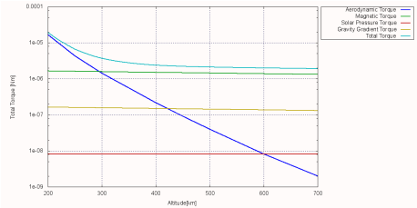](http://www.raumfahrt.fh-aachen.de/compass2/images/adcs_torques.png)](http://www.raumfahrt.fh-aachen.de/compass2/images/adcs_torques.png" \t "_blank)*[Figure 1:  
Diagramm of Disturbance Torques](http://www.raumfahrt.fh-aachen.de/compass2/images/adcs_torques.png" \t "_blank)*To calculate and develop an attitude control system it is necessary to know what the maximum of disturbance torques is on the C-2 nano satellite. At this the following environment influences have to be considered:

* Gravity Gradient
* Solar Pressure
* Aerodynamic Drag
* Earth Magnetic Field

For the first interpretations of the actuators it is enough to estimate the disturbance torques conservatively, but to implement the regulation of the actuators and to optimize them, a simulation of the disturbance and actuating torques is absolute necessary.  
  
**Actuators:**  
To realize the generic concept of COMPASS-2 the ADCS team has to develop all actuators, because of the low volume budgets given by the CubeSat standards the actuators have to get miniaturized. The following actuators are getting developed to get implemented on the C-2 Triple-CubeSat:

* [[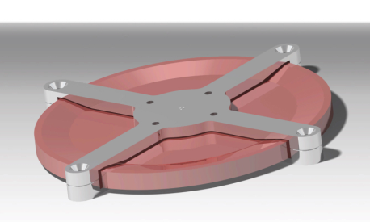](http://www.raumfahrt.fh-aachen.de/compass2/images/adcs_rw.png)  
  *Figure 2: Reaction Wheel*](http://www.raumfahrt.fh-aachen.de/compass2/images/adcs_rw.png)**Reaction Wheels:** The reaction wheels are the actuators with the most actuating accuracy, but also quite interference-prone. The special challenge on developing is to observe the geometrical sizes given by the structure. This challenge is already mastered on the construction. According to latest design the reaction wheel hast the following performance characteristics:
  + max. speed of 40,000 rotations per minute
  + max. power consumption of 0.649 [W]
  + max. actuating time without desaturating of more than 1 hour (on continuous maximum disturbance torque)
  + height of 6 [mm]
  + diameter of 60 [mm]

With this characteristics the reaction wheels are a many times more powerful than comparable reaction wheels on other CubeSats.

* **Magnetorquers:** Contrary to the first satellite of the FH Aachen COMPASS-1 the second will be equipped with ferrite coils. The decision for these is made because of the obvious better performance characteristics.  
  The Magnetorquers are needed in all configurations, because they are the only actuators which are able to detumble the satellite in an acceptable period of time.
* **Gravity Gradient Boom (passive):** The gravity gradient boom is the only passive actuator which will be delivered to the C-2 Triple-CubeSat. It is especially for redundancy, because it does not need any power or active regulation.   
  However the boom has the lowest attitude accuracy and the oscillation caused by the boom prevents the use of the reactionwheels.

**Sensor Technology:**  
Without exact sensors the best attitude actuators cannot work, because the accuracy of the active actuators is only as good as the measured attitude. Therefore the sensor technology is very important for a well done attitude control system. Like on the actuators the sensors will be implemented redundantly:

* **Digital Sun Sensors (DSS):**[[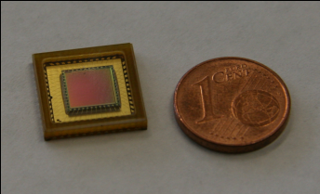](http://www.raumfahrt.fh-aachen.de/compass2/images/adcs_dss.png)  
  *Figure 3:  
  Digital Sun Sensor*](http://www.raumfahrt.fh-aachen.de/compass2/images/adcs_dss.png) These sensors are CMOS image sensors which are detecting light points on a photosensitive pixel area. Further the sensors are differentiating outgoing signal to generate sub pixels and increase the accuracy.
* **3-Axis Magnetometer:** The magnetometer is absolutely necessary for running the magnetorquers. Further they are needed as a reference for calculating the sun vector.
* **Spin Rate Sensor (Gyro):** The Gyro is only for redundancy. This sensor delivers a reference to the calculated tumbling frequency calculated by the DSS and the magnetometer.

http://www.raumfahrt.fh-aachen.de/compass2/design/small_content_bt.png