**Onboard Computer**

The OnBoard Computer (OBC) is the brain of the satellite and it features a Siemens C161 micro controller which combines low power consumption with great performance. It operates at 10MHz and has got 4 Mb of RAM of which the picture will take about 2Mb. Further the OBC has 512kB of PROM which will hold the initial software and further it has 256kB of flash ROM which will be used to upload new software to the satellite after launch. The hardware interfaces are: the power line and boot-selector from the PSU, I2C connections from PSU and ACS, a combined DMA and I2C interface to the camera and a parallel interface to the COM-unit. 



**I2C:** The OBC is the master of the I2C-bus on the satellite and the PSU, ACS and camera subsystems are slaves, which only responds to requests fromt the OBC. The i2C-bus is used for two primary purposes; firstly it is used to acquire housekeeping information from the various subsystems and secondly it is used to send commands to the subsystems.   
  
  
**Boot-mode:** The OBC has the option of booting either on a PROM with the orginal software the satellite was launched with or on FLASH-ROM with contains new software uploaded to the satellite from the ground station. This boot selection is controlled by the PSU by a special algorithm which continuesly tries to boot the OBC from either PROM or flash until it has been succesfully booted.   
  
  
**Camera control:** The command interface to the camera is the I2C-bus, but when the picture is taken it is moved directly into the RAM of the OBC by a DMA interface. During this time the C161 MCU of the OBC is disabled from the databus and executes camera control code from an internal RAM-space of 2kb.   
  
  
**Software:** At this moment approximately 200kb of code has been implemented for the OBC. The responsabilities of this code are mainly:  
- Controls the actions of the satellitebased on a flightplan uploaded from the ground station  
- Collects and store housekeeping information from all subsystems  
- Calculates the attiude of the satellite with regards to the sun based on sensor data from the ACS subsystem  
- Manages communication with the ground station using the AX25 protocol  
- Logs everything that goes on on the satellite to a central satellite log  
More information on the software can be found in the documents below.   
  
  
  
Design space and Print Curcuit Board (click to enlarge):

[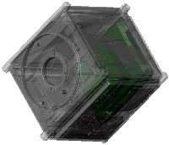](http://www.space.aau.dk/cubesat/pictures/lcto/obc.jpg) [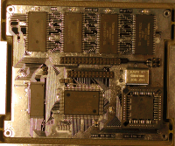](http://www.space.aau.dk/cubesat/pictures/lcto/obc_top.jpg)