

<http://www.qsl.net/kd2bd/predict.html>

**Introduction**

**PREDICT** is an [open-source](http://www.opensource.org/), multi-user satellite tracking and orbital prediction program written under the [Linux operating system](http://www.qsl.net/kd2bd/linux.html) by [John A. Magliacane, KD2BD](http://www.qsl.net/kd2bd/index.html). **PREDICT** is [free software](http://www.gnu.org/philosophy/free-sw.html). Users may redistribute it and/or modify it under the terms of the [GNU General Public License](http://www.gnu.org/licenses/gpl.html) as published by the [Free Software Foundation](http://www.fsf.org/), either version 2 of the License or any later version.

**PREDICT** software is released in three forms:

* A version compatible with Linux or Unix operating systems (as well as some derivatives, such as Mac OS X),
* A version for DOS and DOS-based operating systems operating on 32-bit CPUs (80386s or better) that contains many, but not all the features and functionality of the Linux/Unix version.
* Bundled as part of an application-specific Linux distribution (**Portable PREDICT Plus!**) that includes a small suite of satellite communication applications in addition to **PREDICT** that can all be booted from a pair of floppy disks. (No permanent installation required.)

**Download PREDICT**

**PREDICT** may be downloaded through the following links:

* [PREDICT Version 2.2.3 for Linux](http://www.amsat.org/amsat/ftp/software/Linux/predict-2.2.3.tar.gz): Released May 15, 2006
* [PREDICT Version 2.2.1d for DOS](http://www.amsat.org/amsat/ftp/software/PC/tracking/predct22.zip): Released November 4, 2002
* [PREDICT Version 2.1.4 for the Sharp Zaurus PDA](http://prdownloads.sourceforge.net/zaurus/predict_2.1.4_arm.ipk?download): Released January 6, 2002
* [Portable PREDICT Plus! - Version 1.0 - builds under Linux](http://www.amsat.org/amsat/ftp/software/Linux/ppplus-1.0.tar.gz): Released February 8, 2005
* [Portable PREDICT Plus! - Version 1.0 - builds under DOS/Windoze](http://www.amsat.org/amsat/ftp/software/PC/tracking/pplus10d.zip): Released February 8, 2005

**Who Uses PREDICT?**

The following organizations have reported using **PREDICT** for satellite tracking/orbital analysis applications:

* NASA: Goddard Spaceflight Center, Greenbelt, Maryland, USA
* US Naval Research Laboratory, Washington, DC, USA
* Interferometrics: AMRAD-OSCAR-27 (Eyesat) Satellite Command Ground Station
* SUNSAT-OSCAR-35 Satellite Command Team
* Stanford University's [Space System Development Laboratory (SSDL)](http://swig.stanford.edu/pub/mercury_old/design/services.html)
* **PREDICT** is also used to calculate the current and future positions of the [International Space Station](http://www.findu.com/cgi-bin/ariss/index.cgi) and the [PCSat satellite](http://www.findu.com/cgi-bin/pcsat.cgi) on several world maps at:[www.findu.com](http://www.findu.com/).
* **PREDICT** is used to make pass predictions and track the real-time location of the International Space Station at the [SPACE.Cweb.NL](http://space.cweb.nl/satellite_tracker.html) web site.
* [AMSAT-NA's On-line Satellite Predictions](http://www.amsat.org/amsat-new/tools/predict/) are powered by **PREDICT**.
* **PREDICT** is used to track the location of the CORONAS-F Orbital Solar Observatory at the [CORONAS Web Site](http://coronas.izmiran.rssi.ru/icc/tracking/). (Site requires JavaScript.)
* [Caltech](http://www.astro.caltech.edu/) has used **PREDICT** in aligning radio telescopes against the position of the sun at several of its observatories.
* **PREDICT** is used to provide [real-time locations](http://www.aber.ac.uk/propag/current_nims.html) of the NIMS (Navy Ionospheric Monitoring System) constellation of satellites.
* **PREDICT** was [used by students at Cornell University](http://cornellsun.com/node/9265) to communicate with fellow Cornell alumnus Ed Lu onboard the ISS in September, 2003.
* **PREDICT** is used by [SISCAL](http://www.siscal.net/credit.htm) (Satellite Information System for Coastal Areas and Lakes).
* **PREDICT** is used by the [ISS Fan Club Web Site](http://www.issfanclub.com/) to track and predict passes of the International Space Station.
* **PREDICT** is used at the European Space Agency's [Chilbolton Observatory](http://www.chilbolton.rl.ac.uk/default.htm) where satellites in the [Galileo Global Navigation System](http://www.esa.int/esaNA/SEM21VMVGJE_galileo_1.html) are tracked and monitored. (A close-up of the second photo on the page showing **PREDICT** in use can be found [here](http://esamultimedia.esa.int/images/galileo/126_2615_H.jpg). A [short video](mms://a562.v144483.c14448.g.vm.akamaistream.net/7/562/14448/v0001/esa.download.akamai.com/13452/wmv/gavnrdef_07032006_wmphigh.wmv) (WMV format) including more observatory views is also available.)

**PREDICT** has also been used as the basis for the creation of several other open source satellite tracking software packages.

**Features**

**PREDICT** provides real-time satellite tracking and orbital prediction information to users and client applications in a variety of ways:

* Through the system console
* Through the command line
* Through a network socket
* Through the generation of audio speech

Data such as a spacecraft's sub-satellite point, azimuth and elevation headings, Doppler shift, path loss, slant range, orbital altitude, orbital velocity, footprint diameter, orbital phase (mean anomaly), squint angle, eclipse depth, the time and date of the next AOS (or LOS of the current pass), orbit number, and sunlight and visibility information are provided on a real-time basis. **PREDICT** can also track (or predict the position of) the Sun and Moon. **PREDICT** also has the ability to control AZ/EL antenna rotators to maintain accurate orientation in the direction of communication satellites. As an aid in locating and tracking satellites through optical means, **PREDICT** can articulate tracking coordinates and visibility information as plain speech.

**Program Operation**

**PREDICT**'s start-up screen lists the program's main functions. Several tracking and orbital prediction modes are available, as well as several utilities to manage the program's orbital database.

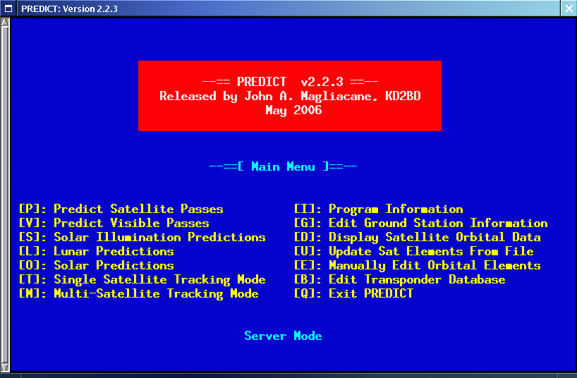

## Predicting Satellite Passes

Orbital predictions are useful for determining in advance when a satellite is expected to come within range of a ground station. They can also be used to look back to previous passes to help to confirm or identify past observations.

**PREDICT** includes two orbital prediction modes to predict any pass above a ground station (main menu option **[P]**), or list only those passes that might be visible to a ground station through optical means (main menu option **[V]**). In either mode, the user is asked to select a satellite of interest from a menu, and then asked to enter the date and time (in UTC) at which prediction calculations should start. Orbital calculations are started and prediction information is then displayed on the screen.

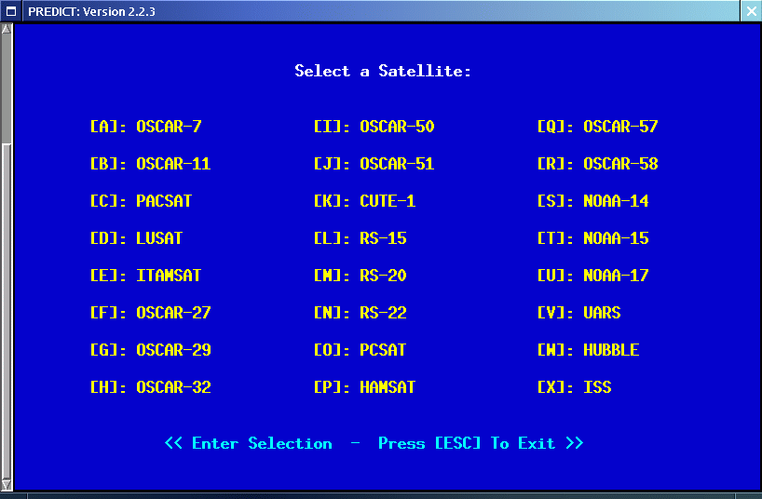

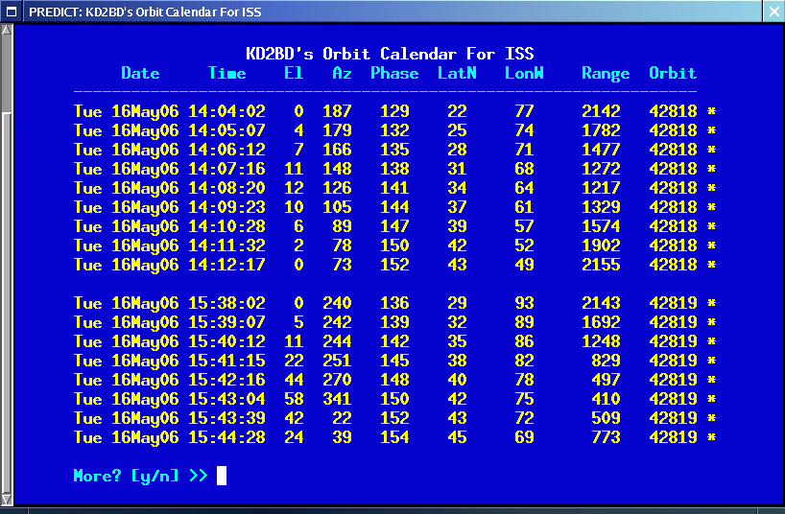

The date and time in UTC, along with the satellite's elevation above ground, azimuth heading, modulo 256 orbital phase, sub-satellite point latitude and longitude, slant range between the ground station and the satellite, and the satellite's orbit number are all displayed. An asterisk (*) displayed to the right of the orbit number means the satellite is in sunlight at the date and time listed on the line. A plus symbol (+) means the satellite is in sunlight while the ground station is under the cover of darkness at the time and date listed. Under good viewing conditions, large satellites such as the International Space Station, and the US Space Shuttles are visible to the naked eye. If no symbol appears to the right of the orbit number, then the satellite is in the Earth's shadow at the time and date listed, and is not receiving any illumination from the sun.

Selecting **[V]** from **PREDICT's** main menu will permit a ground station to only predict passes for satellites that are potentially visible through optical means. Since all other passes are filtered out in this mode, and since some satellites may never arrive over a ground station when optical viewing conditions are possible, the program provides the option of breaking out of visual orbital prediction mode by pressing the [ESC]ape key as calculations are made. A prompt is displayed at the bottom of the screen to alert the user of this option.

In either orbital prediction mode, predictions will not be attempted for satellites that can never rise above the ground station's horizon, or for satellites in geostationary orbits. If a satellite is in range at the starting date and time specified, **PREDICT** will adjust the starting date back in time until the point of AOS so that the prediction screen displays the first pass in its entirety from start to finish.

## Single Satellite Tracking Mode

In addition to predicting satellite passes, **PREDICT** allows satellites to be tracked individually in real-time using **PREDICT's** Single Satellite Tracking Mode (main menu option **[T]**), or simultaneously as a group of 24 using the program's Multi-Satellite Tracking Mode (main menu option **[M]**). The positions of the Sun and Moon are also displayed when tracking satellites in real-time.

Selecting option **[T]** from **PREDICT's** main menu places the program in Single Satellite Tracking Mode. The user will be prompted to select the satellite of interest, after which a screen will appear and display tracking positions for the satellite selected.

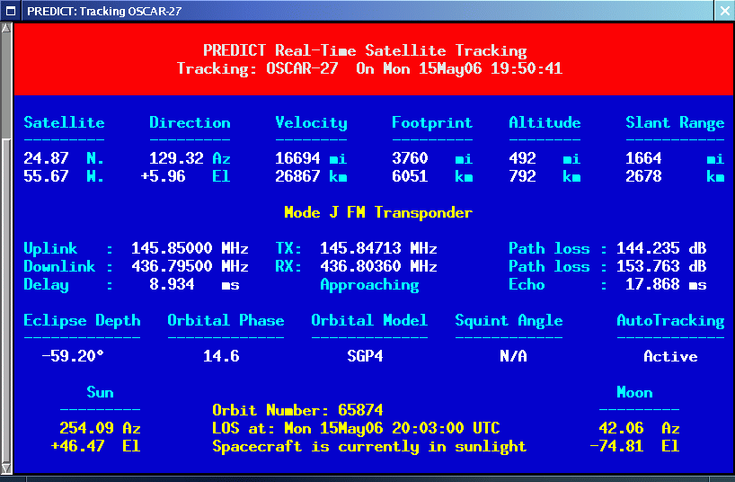

In Single Satellite Tracking Mode, a wealth of real-time satellite data is provided by **PREDICT**. If the satellite contains an active communications downlink, uplink, or two-way communications transponder, then Doppler-corrected uplink and downlink frequencies, path loss, propagation delay, and echo are displayed. It is also possible to tune across the transponder's passband using certain keystrokes to locate a specific uplink or downlink frequency within the satellite's transponder. This makes it possible to determine the appropriate uplink frequency to match a desired downlink frequency (or vice-versa). **PREDICT** supports a number of transponders per satellite, including linear (both inverting and non-inverting), digital (Pacsat), and bent-pipe (FM). Also new to version 2.2.x is the determination of antenna squint angle and solar eclipse depth.

If a soundcard is present in your machine and the Single Satellite Tracking Mode is invoked with an uppercase 'T' rather than a lowercase 't', **PREDICT** will make periodic voice announcements stating the satellite's tracking coordinates in real-time. Announcements such as:

***"***[***This is PREDICT. Satellite is at fifty six degrees azimuth and forty five degrees elevation, and is approaching. Spacecraft is currently visible.***](http://www.qsl.net/kd2bd/predict.mp3)***"***

are made at intervals that are a function of how quickly the satellite is moving across the sky. Announcements can occur as frequently as every 50 seconds for satellites in low earth orbits such as the International Space Station (370 km), or as infrequently as every 8 minutes for satellites in very high orbits, such as the GE-2 geostationary satellite (35780 km). Voice announcements are performed as background processes so as not to interfere with tracking calculations as the announcements are made. Announcements can be forced at any time by pressing the 'T' key in Single Satellite Tracking Mode. Alarms are sounded at the precise moment when satellites enter into sunlight or into eclipse.

## Solar Illumination Predictions

**PREDICT** even makes it possible to determine how much solar illumination a particular satellite will receive over the course of a day. This information is especially valuable to spacecraft designers and satellite groundstation controllers who must monitor spacecraft power budgets or thermal conditions on-board their spacecraft due to sunlight and eclipse periods. It can even be used to predict the optimum times for astronauts to perform extra-vehicular activities in space.

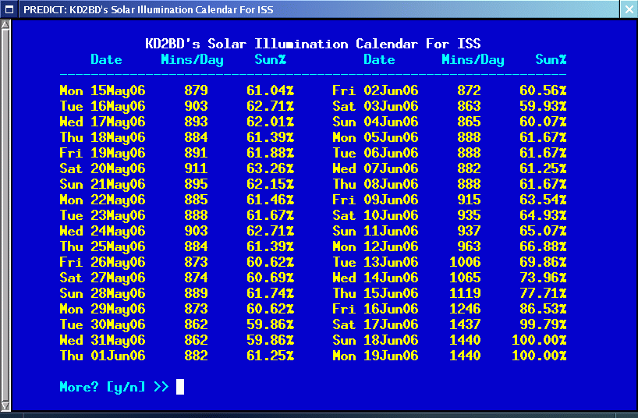

## Multi-Satellite Tracking Mode

Selecting **[M]** from **PREDICT's** main menu places the program in a real-time multi-satellite tracking mode. In this mode, all 24 satellites in the program's database are tracked simultaneously along with the positions of the Sun and Moon. Tracking data for the satellites is displayed in two columns of 12 satellites each. The name, azimuth heading, elevation, sub-satellite point latitude (in degrees North) and longitude (in degrees West) positions are provided, along with the slant range (in kilometers), and the slant range distance between the satellite and the ground station (also in kilometers).

A letter displayed to the right of the slant range indicates the satellite's sunlight and eclipse conditions. If the satellite is experiencing an eclipse period, an N is displayed. If the satellite is in sunlight and the ground station is under the cover of darkness, a V is displayed to indicate the possibility that the satellite is visible under the current conditions. If the satellite is in sunlight while conditions at the ground station do not allow the satellite to be seen, a D is displayed. Satellites in range of the ground station are displayed in **BOLD** lettering. The AOS dates and times for the next three satellites predicted to come into range are displayed on the bottom of the screen between the tracking coordinates of the Sun and Moon. Predictions are not made for satellites in geostationary orbits or for satellites so low in inclination and/or altitude that they can never rise above the horizon of the ground station.

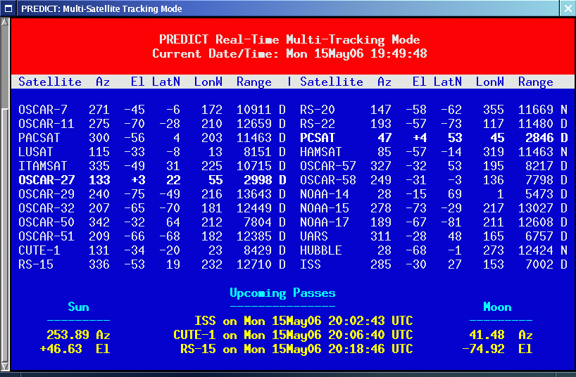

## Solar and Lunar Orbital Predictions

In addition to making orbital predictions of spacecraft, **PREDICT** can also predict transits of the Sun and the Moon. When making solar and lunar orbital predictions, **PREDICT** provides azimuth and elevation headings, the right ascension, declination, Greenwich Hour Angle (GHA), radial velocity, and normalized distance (range) to the Sun or Moon.

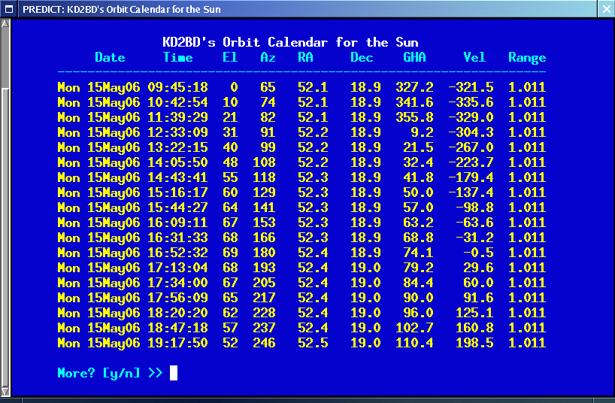

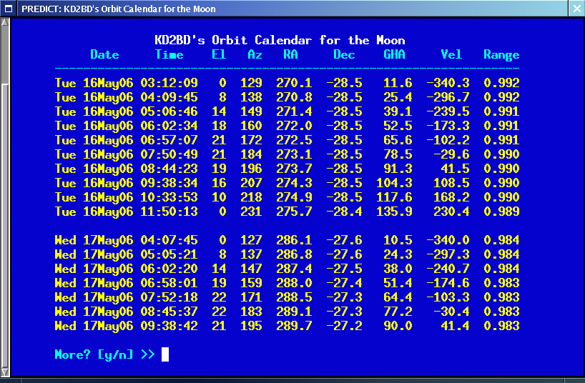

The Declination and Greenwich Hour Angles correspond to the latitude and longitude of the object's sub-satellite point above the Earth's surface. The radial velocity corresponds to the speed and direction the object is traveling toward (+) or away (-) from the ground station, and is expressed in meters per second. When the radial distance of the Moon is close to zero, the amount of Doppler shift experienced in Moon bounce (EME) communications is minimal. The normalized distance corresponds to the object's actual distance to the ground station divided its average distance. In practice, the normalized distance can range from about 0.945 to 1.055 for the Moon, and about 0.983 to 1.017 for the Sun.

## EME Support

Included with **PREDICT** is a utility called **MoonTracker**. **MoonTracker** supports moonbounce (EME) communications by calculating the position of the Moon, and sending appropriate control signals to an AZ/EL antenna rotator to track the Moon as it crosses the sky. Once invoked, **MoonTracker** spawns itself as background process, and continues to run until terminated by a kill signal. If the Moon is not above the horizon when **MoonTracker** is invoked, **MoonTracker**goes to "sleep" until the predicted time of Moon rise.

## Client Applications

The Linux version of **PREDICT** includes networking code to permit its use as a socket-based server, allowing it to supply real-time tracking and orbital prediction information to client applications using the UDP communications protocol. A number of excellent client applications have been developed thus far for use with **PREDICT**, and more are on the way.

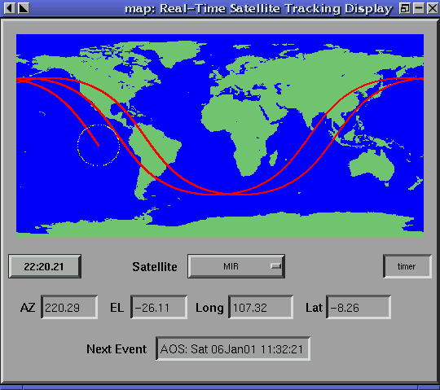

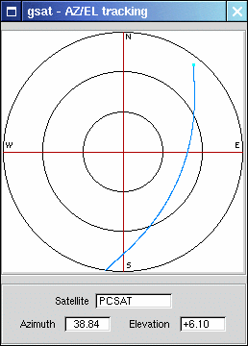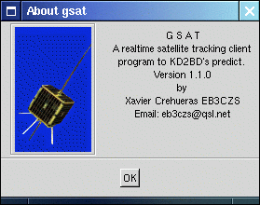

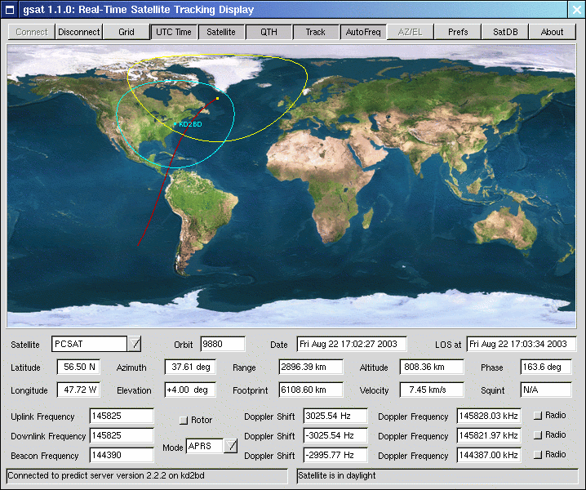

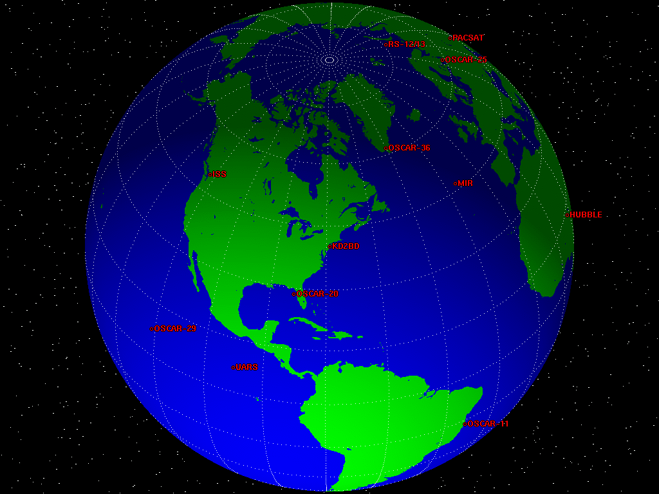

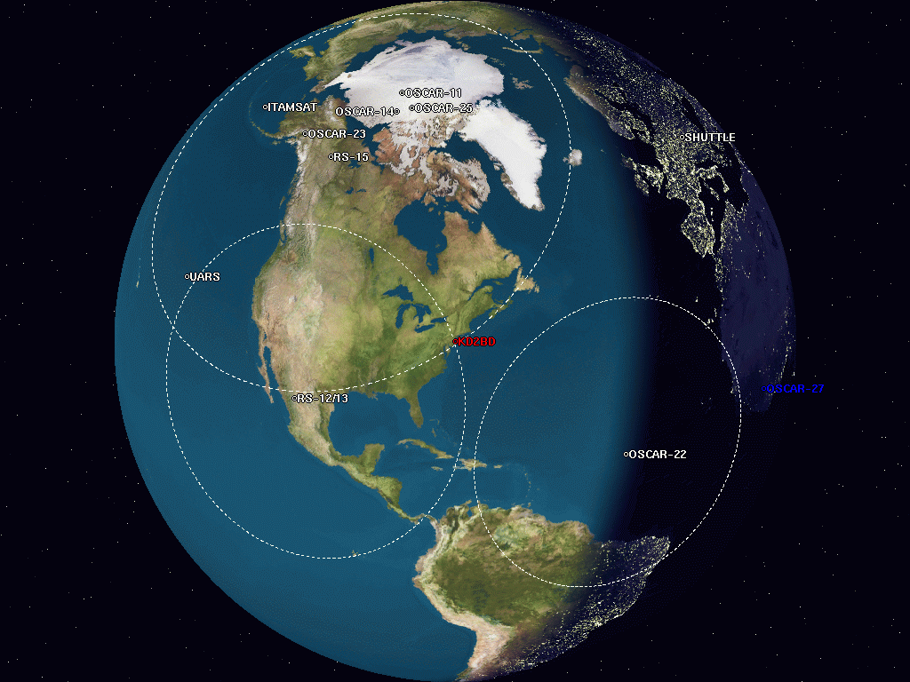

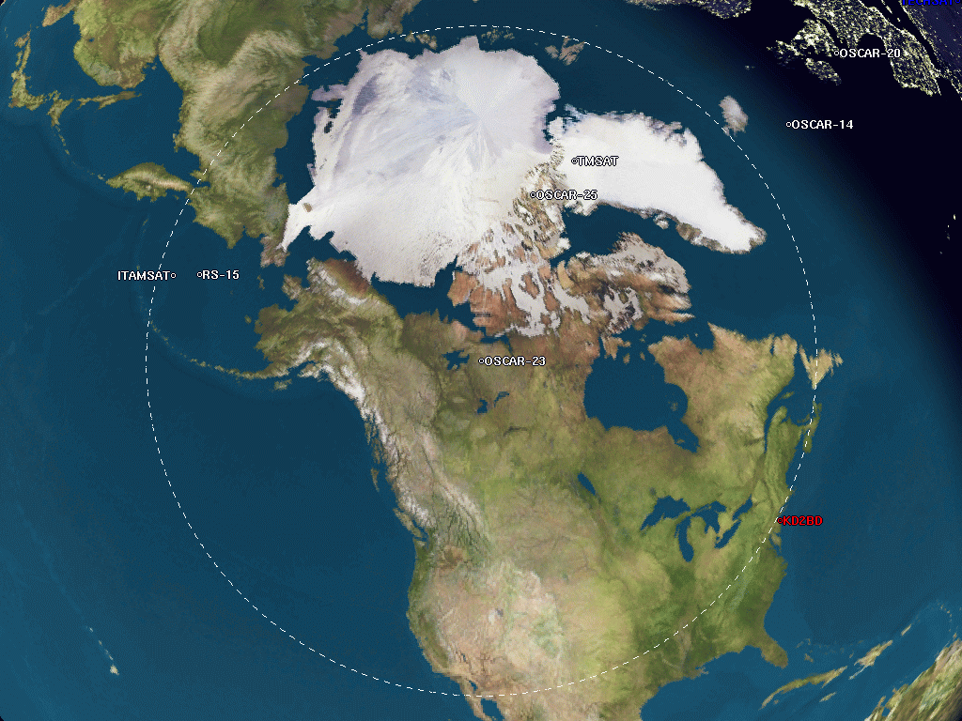

The graphical client applications pictured above are included as part of the Linux version of **PREDICT**.

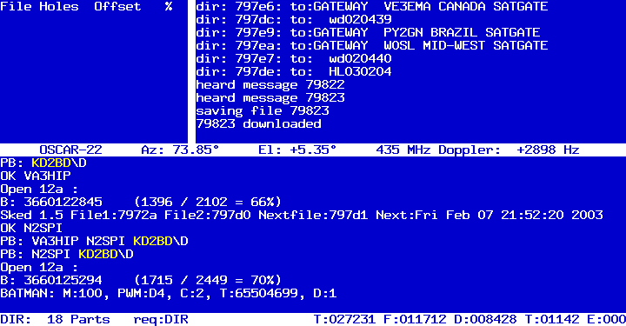

The latest version of PB/PG (a Pacsat communication suite) for Linux written by Bent Bagger, OZ6BL polls **PREDICT** for live tracking data, and displays the information in the center of PB's main screen.

**Antenna Tracking Hardware**

Hardware and software utilities have been created to work in concert with **PREDICT** and **MoonTracker** to permit automatic AZ/EL antenna tracking of satellites and the Moon. To date, compatible AutoTracking solutions have been developed by:

* [PIC/TRACK Antenna Rotator Controller](http://digilander.iol.it/iw3fol/pictrack.html) by Vicenzo Mezzalira
* [SAI Dish Controllers](http://www.ultimatecharger.com/Dish_Controllers.html) by Suding Associates, Inc.
* [EasyTrak, Jr.](http://www.tapr.org/) by TAPR, the Tucson Amateur Packet Radio Corporation (Currently under development)
* [FODTRACK rotator interface](http://www.qsl.net/lx2gt/fodtrack/) utility written by Luc Langehegermann, LX2GT.

***PREDICT****software is Copyright © 1991-2010 by*[*John A. Magliacane, KD2BD*](http://www.qsl.net/kd2bd/index.html)*.  
For information on other software written by this author, please see*[*the software page.*](http://www.qsl.net/kd2bd/software.html)

hat are a function of how quickly the satellite is moving across the sky. Announcements can occur as frequently as every 50 seconds for satellites in low earth orbits such as the International Space Station (370 km), or as infrequently as every 8 minutes for satellites in very high orbits, such as the GE-2 geostationary satellite (35780 km). Voice announcements are performed as background processes so as not to interfere with tracking calculations as the announcements are made. Announcements can be forced at any time by pressing the 'T' key in Single Satellite Tracking Mode. Alarms are sounded at the precise moment when satellites enter into sunlight or into eclipse.