**Communication**

The COM unit of the satellite consists of two parts: a modem part and a radio part. The modem is a MX909 modem-chip which runs at 9600 baud and features GMSK, scrambling, checksumming, forward error correction and interleaving while using the Mobitex standard.   
Read more about Mobitex and MX909:

• [mx909a.pdf](http://www.space.aau.dk/cubesat/datasheets/mx909a.pdf)

• [gmsk.pdf](http://www.space.aau.dk/cubesat/datasheets/gmsk.pdf)  
  
  
The radio is the SX450 from Wood And Douglas with a transmitting power of 500 mW. 

[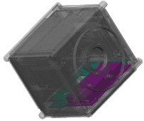](http://www.space.aau.dk/cubesat/pictures/lcto/com.jpg)