**Information for Radio Amateurs**

The satelitte received its frequency through AMSAT and we are therefore commmited to serve the radio-amateur community as part of our mission. This page will provide more details for radio-amateurs who are interested in our satelitte.  
  
It should be noted that initially the satelitte does not implement any functionality with the radio-amateur community in mind, because at first we have to establish connection and evaluate the performance of the subsystems. Following that phase we can begin to upload new software to the satelitte that includes services for radio-amateurs. Basically we want the satelitte to well up and running before letting anybody else "fool around" with it. If you have ideas for uses of the satelitte following the initial phase then let us know.  
  
The kepler elements for the satelitte, as of the 10th September 2003 are:  
AAU CUBESAT  
1 27846U 03031G 03250.46633699 .00000182 00000-0 10513-3 0 412  
2 27846 98.7287 256.4998 0010407 87.6191 272.6177 14.20512143 9764  
  
For the most recent elements goto: [Data at celestrak.com](http://www.celestrak.com/NORAD/elements/science.txt)and find "AAU-cubesat".You will also be able to get azimuth and elevation data (as seen from Aalborg) at our "whereis" page.  
  
As the signal is very weak - wo don't know why - it is very difficult to receive the signal so far the following stations have been able to pick it up:  
- Original groundstation at Aalborg university. First signal on the 1st of July  
- Radio amateur Ib Christoffersen (OZ1MY). Possible signal on the 2nd of July  
- The CanX-1 groundstation in Toronto. First signal on the 3rd of July  
- Carsten Grøn's 8m amateur dish. First signal on the 26th of July  
  
**Frequencies, Modulation and Packet Format**

The frequency is: 437.450MHz   
The modulation scheme is GMSK at 9600baud  
The packet format is dictated by the MX909 modem, please consult the datasheet for details. [**MX909**](http://www.space.aau.dk/cubesat/datasheets/mx909a.pdf). The bit-sync pattern used is: 0x3333, and the used frame sync pattern is: 0xF0AA. Each MX909 packet encapsulates a single AX25-frame.  
  
If you want to build a modem your self then you will require a modem PCB connected to a computer that runs the driver software. In our case we have build a modem PCB that interfaces to a MCB167 evaluation board that drives the modem and transmits AX25-frames to and from a standard PC. The following files is a our modem desing and driver software for the MCB167 board. You can use this as a starting point, if you have questions then let us know:  
- Modem driver code for MCB167 board [**ZIP-FILE**](http://www.space.aau.dk/cubesat/documents/driver.zip)

**The Beacon Signal**

When not in the radio-window of the groundstation in Aalborg (Denmark) the satellite will transmit a beacon signal once every minute. This signal is a AX25 UI frame encapsulated in a MX909 packet. If you decode the information field of the UI frame you will find the following information:  
- A 15 byte duplicate of the AX25 frame header   
- An 18 byte text string "www.cubesat.auc.dk" if satelitte is running from PROM memory, and the same string in upper-case if it is running from FLASH-memory  
- The time from last reset in seconds. 4 bytes   
- Number of software errors. 2 bytes   
- OBC temperature. 4 bytes   
- Battery Voltage. 2 Bytes   
  
Byte ordering is little endian, signal length is 120ms  
  
If you pick up the beacon signal (you don't have to be able to decode it) then please mail to [Lars Alminde](mailto:lalm00@control.auc.dk) In the mail include: position of you ground station, the time the signal was picked up and the orientation and type of your antennas. Feel free to add as much additional information on the signal as possible.

Below is an example of an advanced beacon received by the 8m dish on the 20th of August:

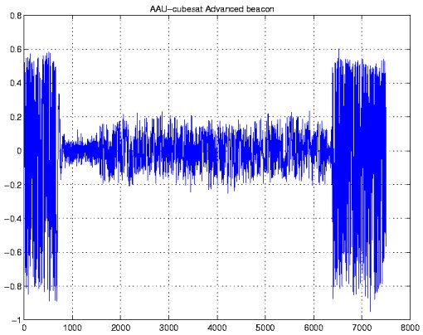

**The Safe Mode Beacon Signal**

If for some reason the on-board computer fails then the power supply (PSU) will use the push to talk signal on the radio to transmit a simple beacon signal every 20 or 40 seconds depending on the battery voltage. The PSU will morse "AAV" (//*-/*-/***-//) (it should have been "AAU" - but there is a bug) followed by a 12 bit value (battery voltage) 1 is /-/ and 0 is /*/. Signal length is approximately 150ms. If you pick up this signal please report it to us.

Below is an example of a basic beacon received by the 8m dish on the 20th of August:

